Name: Date: short (oo) words

The short (oo) sound is usually represented by the letters oo.

Remember: Say the word aloud, then say each letter aloud as you write it e.g. 'good, g ... o ... o ... d'

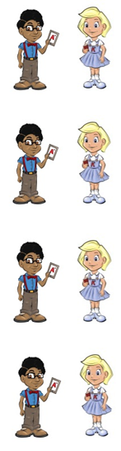
Gary is always good.

You can wear a hood in the rain.

Nina stood behind Gail to trick her.

A wood is a place with lots of trees.

The words could, should and would are naughty red words that belong to Nina and Neil because the letters oul make the short (oo) sound.
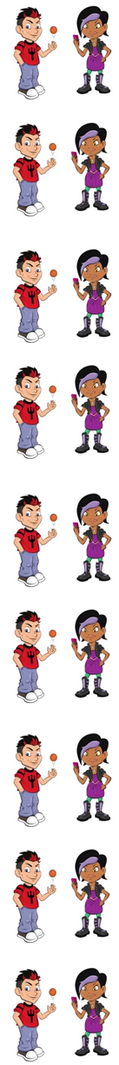
This could be a hard word to spell.

Even Gary would find these words hard to learn.

These words should not be so hard to spell!

The words blood and flood are naughty red words that belong to Nina and Neil because the letters oo make the short (u) sound, like in mud.
A river can flood if there is a lot of rain.

Your heart pumps blood.

Now test yourself without looking at the words and check for yourself if you got them all right. Practice writing any words that you made mistakes on again.

© www.SaveTeachersSundays.com 2013
Name: Date: short (oo) words

The short (oo) sound is usually represented by the letters oo.

Remember: Say the word aloud, then say each letter aloud as you write it e.g. 'good, g ... o ... o ... d'

Try to spell each word without looking at it.

Gary is always .

You can wear a in the rain.

Nina behind Gail to trick her.

A is a place with lots of trees.

This be a hard word to spell.

Even Gary find these words hard to learn.

These words not be so hard to spell!

A river can if there is a lot of rain.

Your heart pumps .

Now check for yourself if you got them all right. Practice writing any words that you made mistakes on again.

© www.SaveTeachersSundays.com 2013

